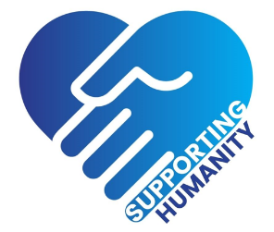
Referral form for mental health services:

Please provide as much information as possible:

Gender:
Male

Female

Prefer not to say

Age:
Under 16.

16-18

18-25

25-30

30-59

60+

Ethnicity:

Contact details:
Address:

Telephone number:

Are you happy for an emotional support volunteer to leave a voicemail/message at any time? Yes No

Preferred time for contact:
8-12:00

12:00-17:00

1700-21:00

Anytime between 08:00-21:00

Clients preferred language: English

If other, please specify:

I would like support/counselling for:
Depression and Anxiety

Bereavement

End-of-life care

Domestic Violence

Addiction/Alcohol rehabilitation

Other: Please specify

Medical/Mental Health History: (please provide as much detail as possible)

Drug History: (please include prescribed drugs and any other drugs)

GP contact details:
Name of GP: GP surgery/practice:
Address:
Contact number:
Thank you for taking the time to complete this form.
All referral forms are screened and referred to the appropriate team. The support you're offered will depend on the problems you're experiencing and how severe they are.
Someone from the Supporting Humanity team will get in touch to ask about the problems you're having.
This service does not provide assistance or support if you need urgent help in a crisis
If you or a loved one are experiencing a mental health crisis, please call a local NHS mental health helpline for 24-hour advice and support by finding your local service by following the link below: https://www.nhs.uk/service-search/mental-health/find-an-urgent-mental-health-helpline or If someone's life is at risk or they cannot be kept safe, call 999 or go to A&E.

Office/Internal use only:

Client ID:

